# VISVESAVARAYA TECHNOLOGICAL UNIVERSITY

Jnana Sangama, Belagavi-590018

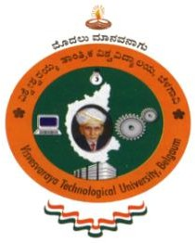

A Synopsis report

On

## “IOT (Internet of Things) Areca Nut Dryer”

*Submitted in partial fulfillment of the requirements for the award of the degree of*

**BACHELOR OF ENGINEERING**

**In**

**ELECTRONICS AND COMMUNICATION ENGINEERING**

**By**

|  |  |  |
| --- | --- | --- |
| **Sr.No** | **Name** | **USN** |
| **1** | **Prajyot Rajgonda Patil** | **4AL21EC057** |
| **2** | **Rakshith** | **4AL21EC067** |
| **3** | **Thejas J. Kotian** | **4AL21EC099** |
| **4** | **Yashwanth G T** | **4AL21EC114** |



**Department of Electronics and Communication Engineering**

**ALVA’S INSTITUTE OF ENGINEERING & TECHNOLOGY**

**Shobhavana Campus, MIJAR-574225, Moodbidri, D.K., Karnataka**

**MAY 2024**

SMART FLOOR CLEANER